

**COMSATS University, Islamabad**

**Department of Computer Science**

**First Sessional Exam, Fall 2020**

**Part-2**

Class/Section: - BSCS – 7 C Marks: - 10

Subject: - Special Topics in CS-1 Time: - 20 Minutes

Instructor: - Muhammad Raza Tayyab Dated: - **April 01, 2021**

**Part B (Total Marks:10) CLO-1**

**WALEED BUTT SP18-BCS-170**

**Question 01:** This basic server sends back a single response header, Content Type, a 200 response status code, and the body, Hello World. Describe what is wrong/missing in the following code:

var http = require('http');

http.createServer(function(req , res ) {

res.writeHead(200, {'Content Type': 'text/plain’});

response.write('Hello World n');

}).listen(1337, '127.0.0.1');

console.log('Server running at <http://127.0.0.1:1337/>');

1. we need to type Content-Type instead of Content Type. (hyphen is missing)
2. We need to use same variable ‘res’ everywhere. Instead of response
3. We need to use res.end instead of response.write

**Question 02:** A file can be read using two different APIs in Node.js. fs.createReadStream and fs.readFile. Describe in 2-3 lines a key advantage of using fs.createReadStream that allows it to read files that might not work with the fs.readFile interface.

**Question 03:** What is the typical first argument to the callback function in node.js. What are the argument’s possible values?

1. Possible arguments to callback functions are request, response, next, data
2. Request contains all the data regarding the request made by user
3. Response decides what to send back to user
4. Data contains the data returned by callback function itself

**Question 04:** What does the following Node.js program output?

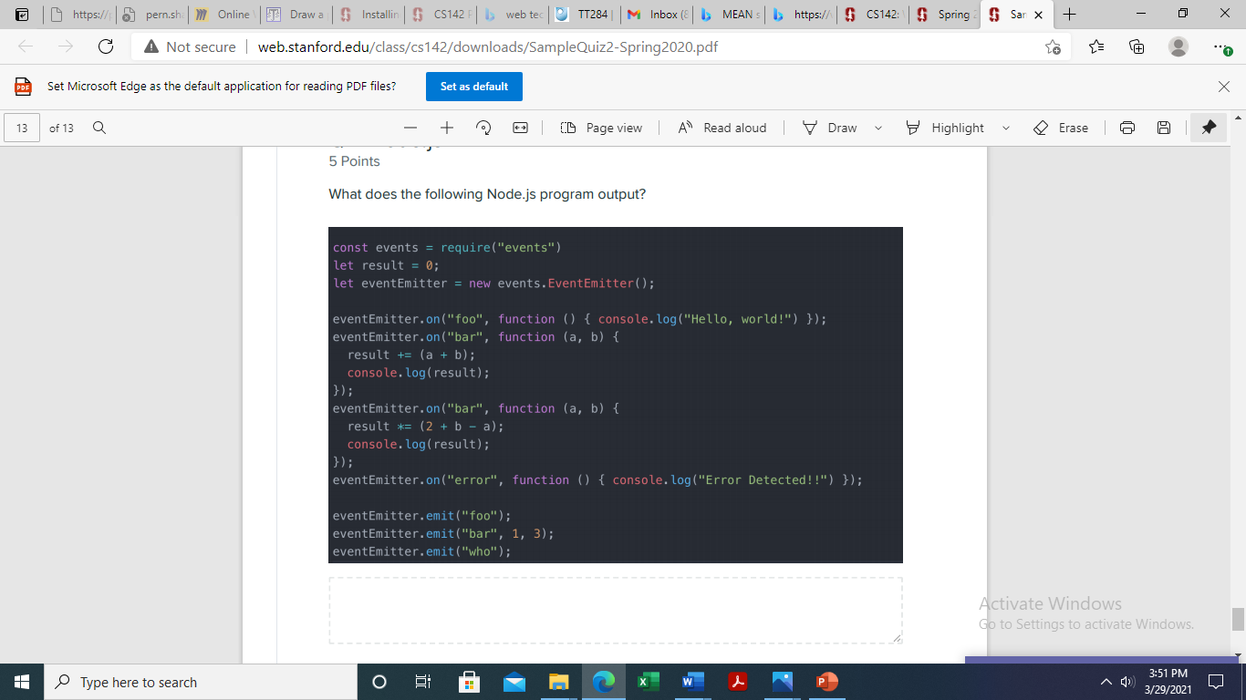

**Answer**

Hello, world!

4

16

**Question 05:** The following Node.js program uses the Node fs module to read a large file twice using two different API calls. When run, the programs print the numbers 1 through 5 to the console.

Answer this question by listing the order in which the numbers are printed. Provide a brief (one or two sentence) explanation of the order in your answer.

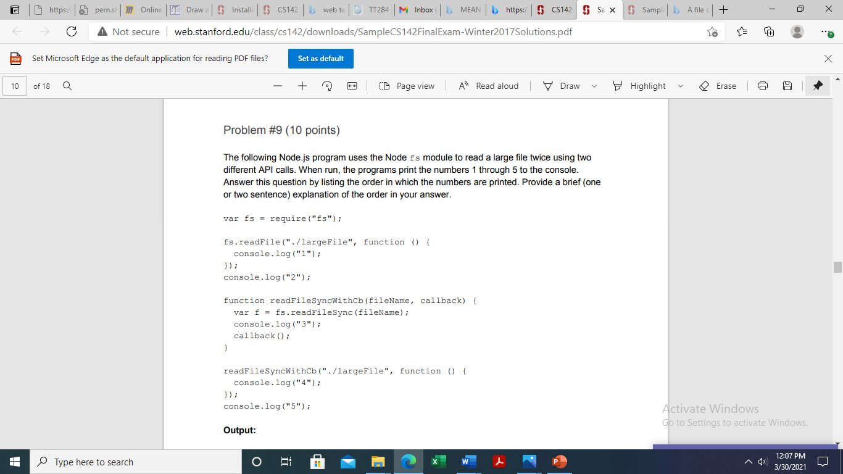

**Answer**

2

3

4

5

1

The functions are asynchronous. Therefore their order of execution is dependent on CPU scheduling. 2 is first printed because it was not an asynchronous call. It executed immediately after function declaration. Same is the case with 3, 4 and 5. But 1 was printed with async call so it appeared in the end.